**HOME PAGE:**



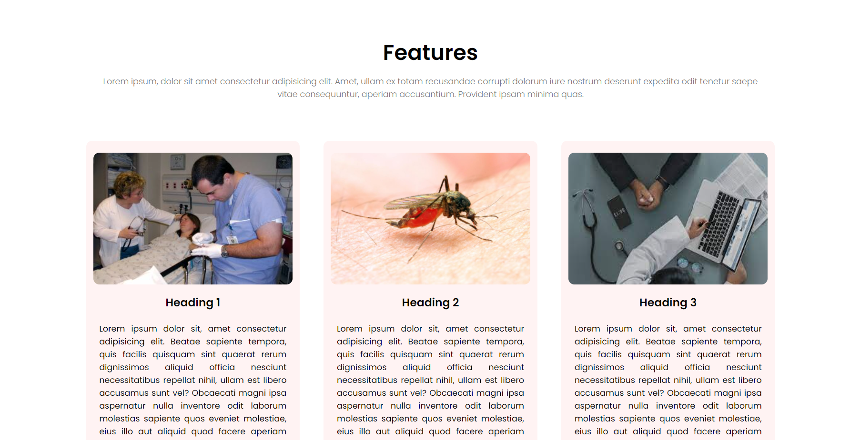

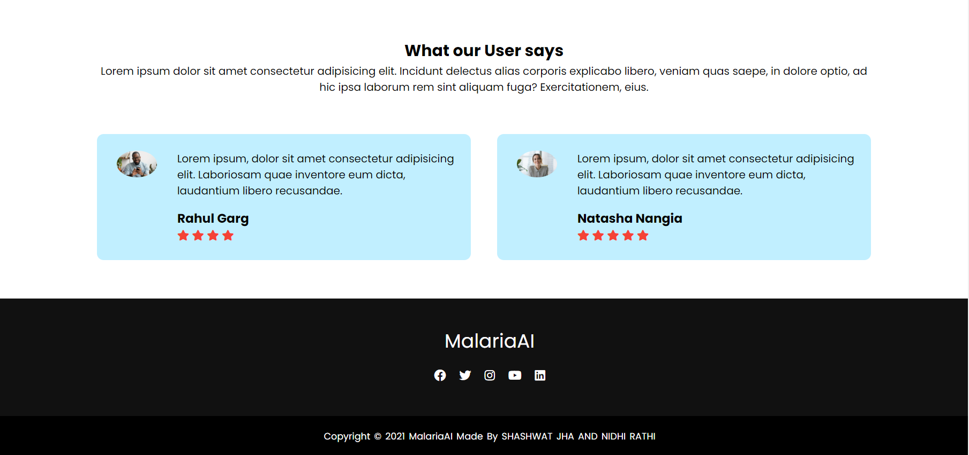

**SIGNING UP ON WEBSITE:**

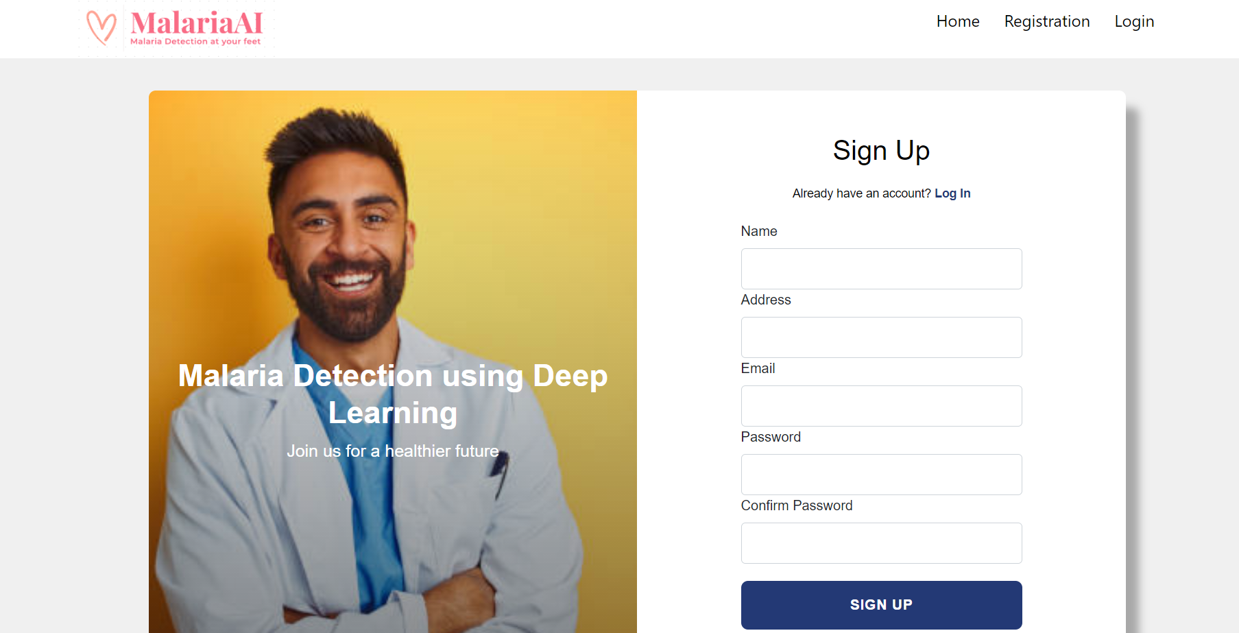

*VALIDATION:*

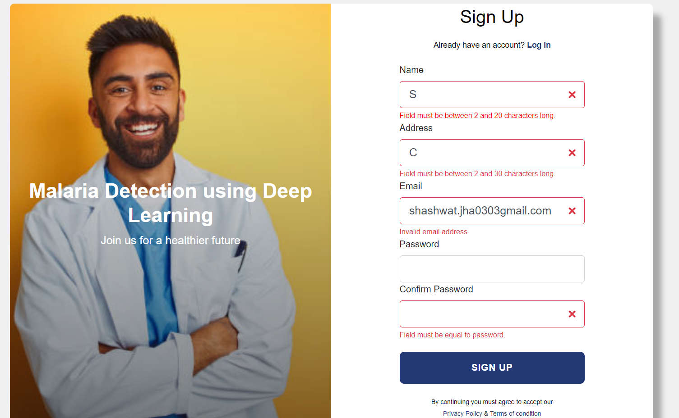

*If someone tries to register with the already registered email:*

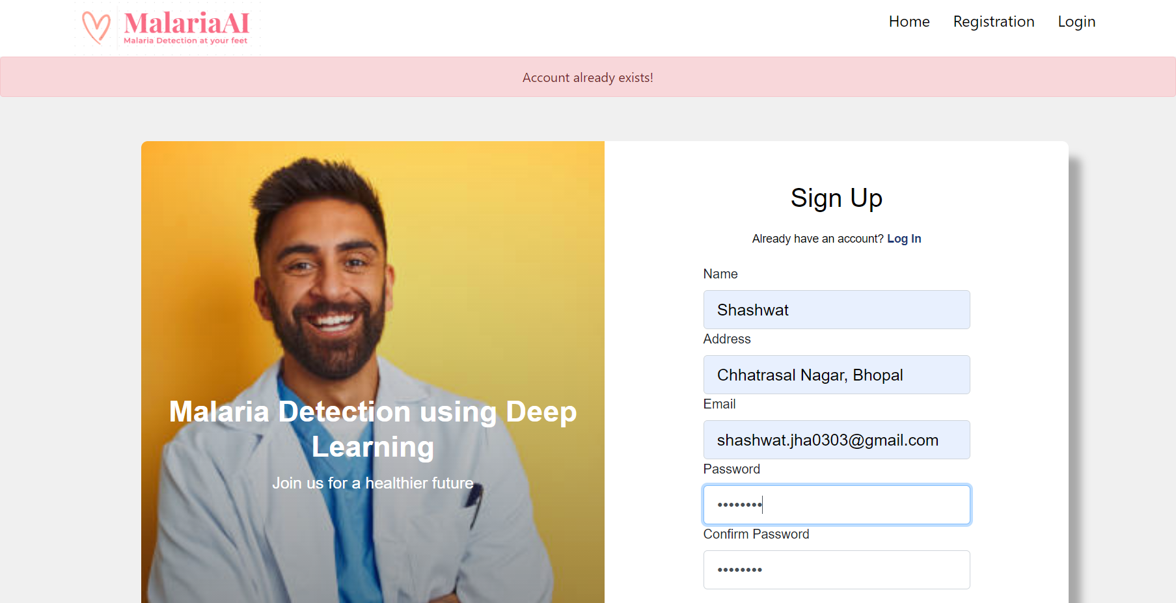



**PAYMENT:**

*After registering on website, it will automatically log you in and direct you to payment page:*

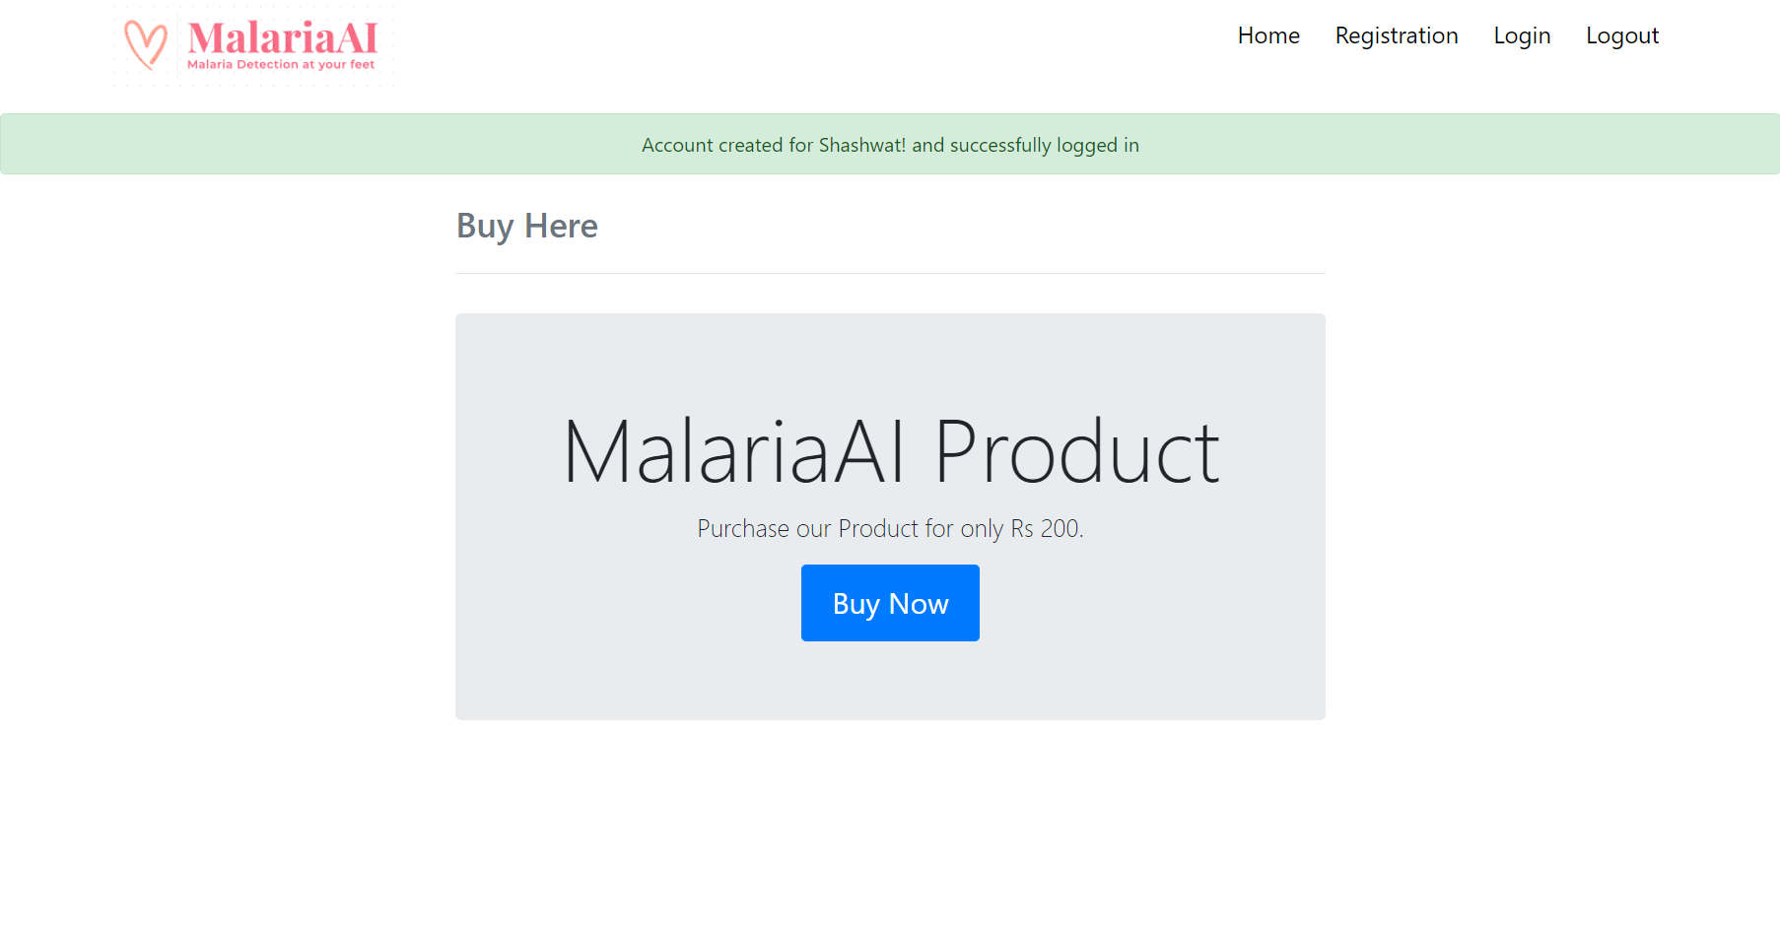

*After clicking “Buy now”, it will redirect you to Payment Gateway*

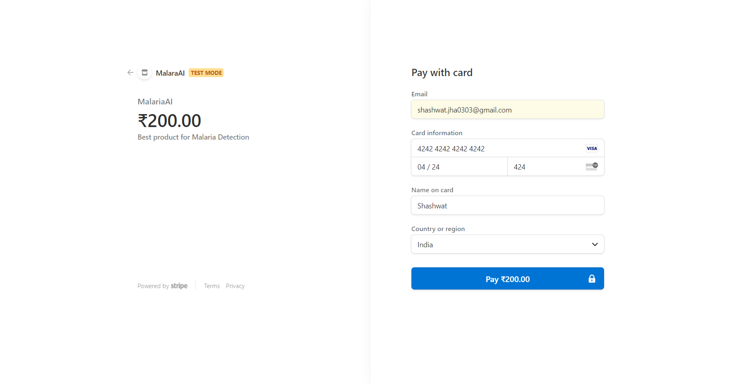

*VALIDATION:*

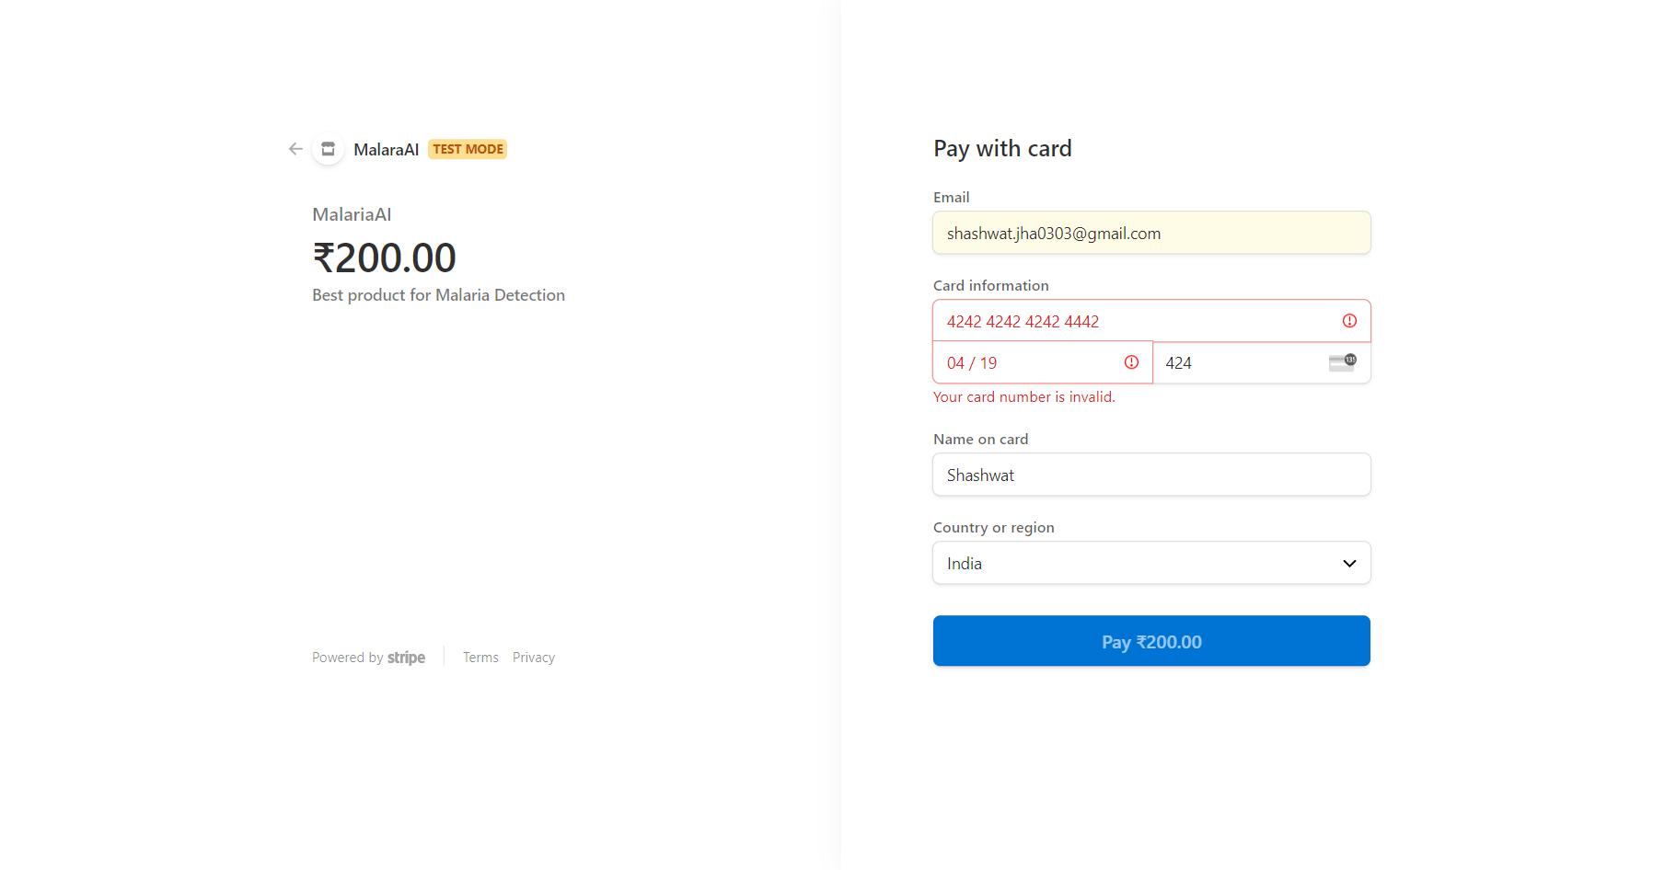

*After successful payment, it will redirect you to image upload section else if payment is unsuccessful, it will again redirect to payment page*

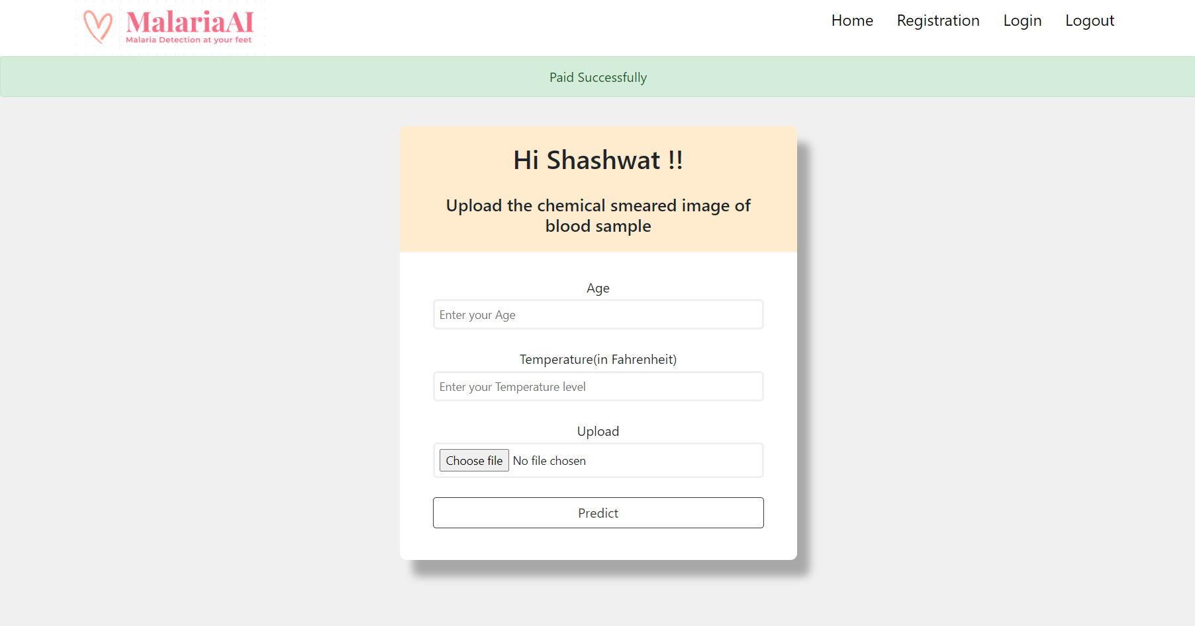



*If we upload a blood smeared image:*

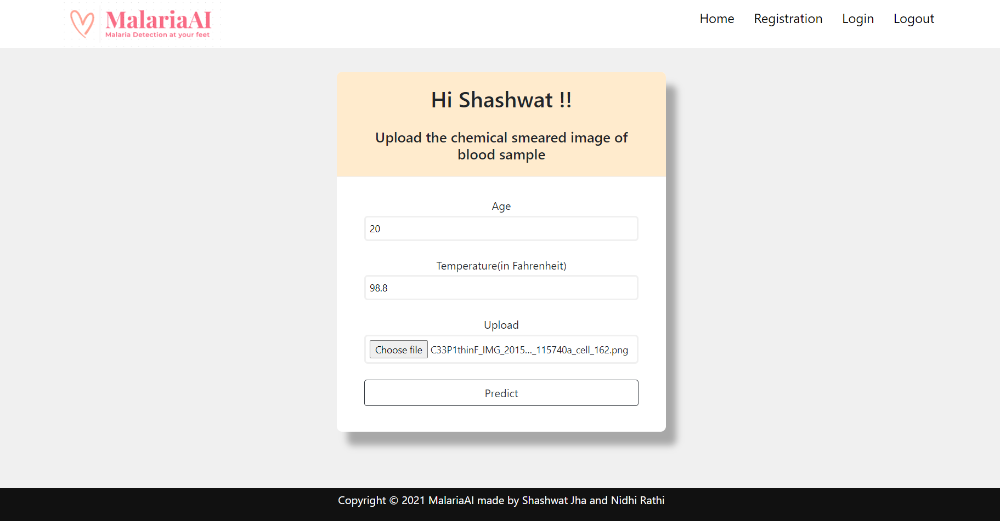

*If the upload is successful, it will direct us to result page to show the result*

**UPLOADING AN IMAGE FOR MALARIA DETECTION IN IMAGE UPLOAD PAGE TO GET THE RESULT:**

***CASE1****: If we upload the given image below which is* ***infected*** *with malaria:*

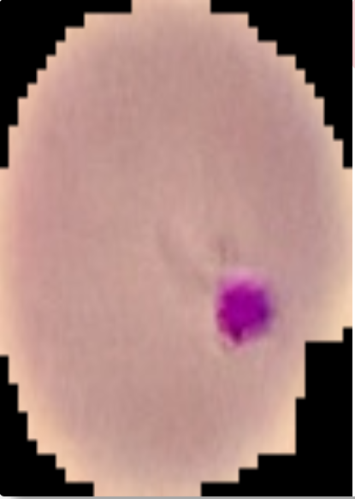

**RESULT**

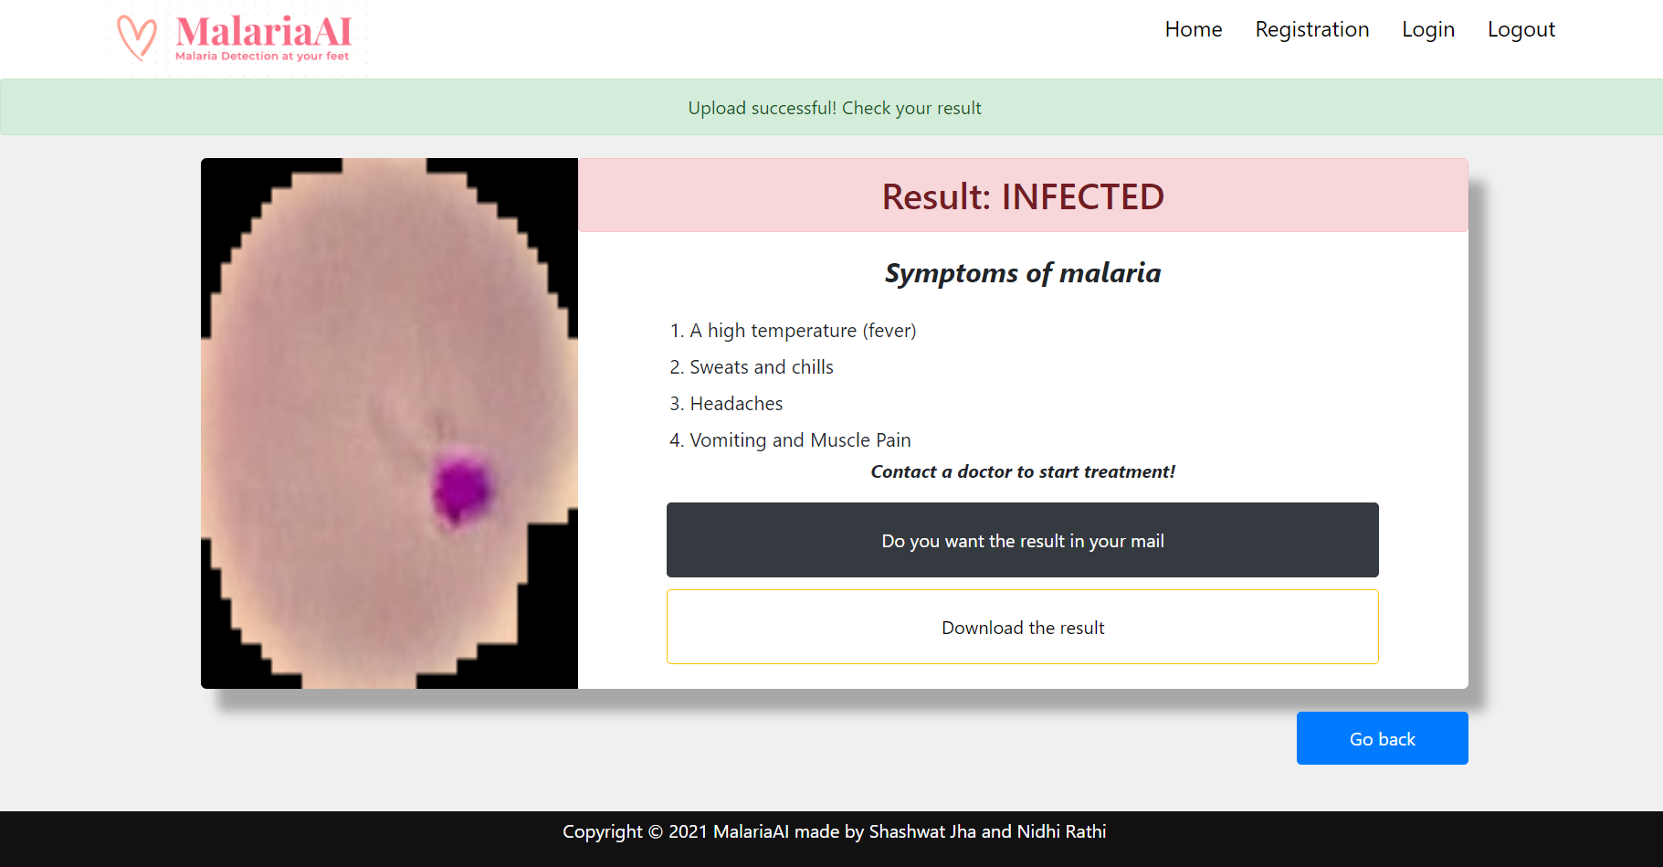

*Email received to if he/she wants their result on mail*

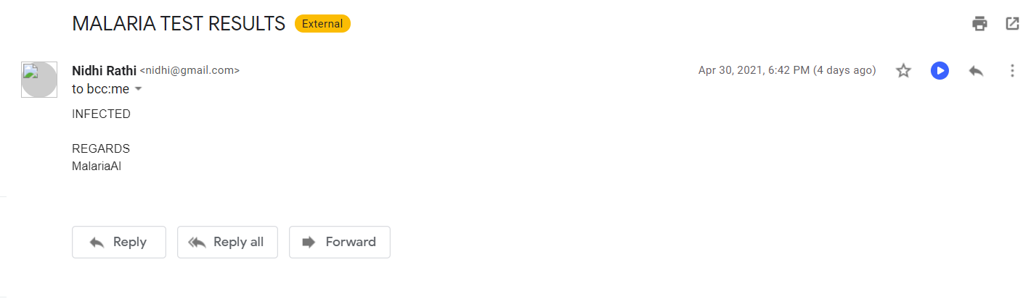

***CASE2****: If we upload the given image below which is* ***not infected*** *with malaria:*



**RESULT:**

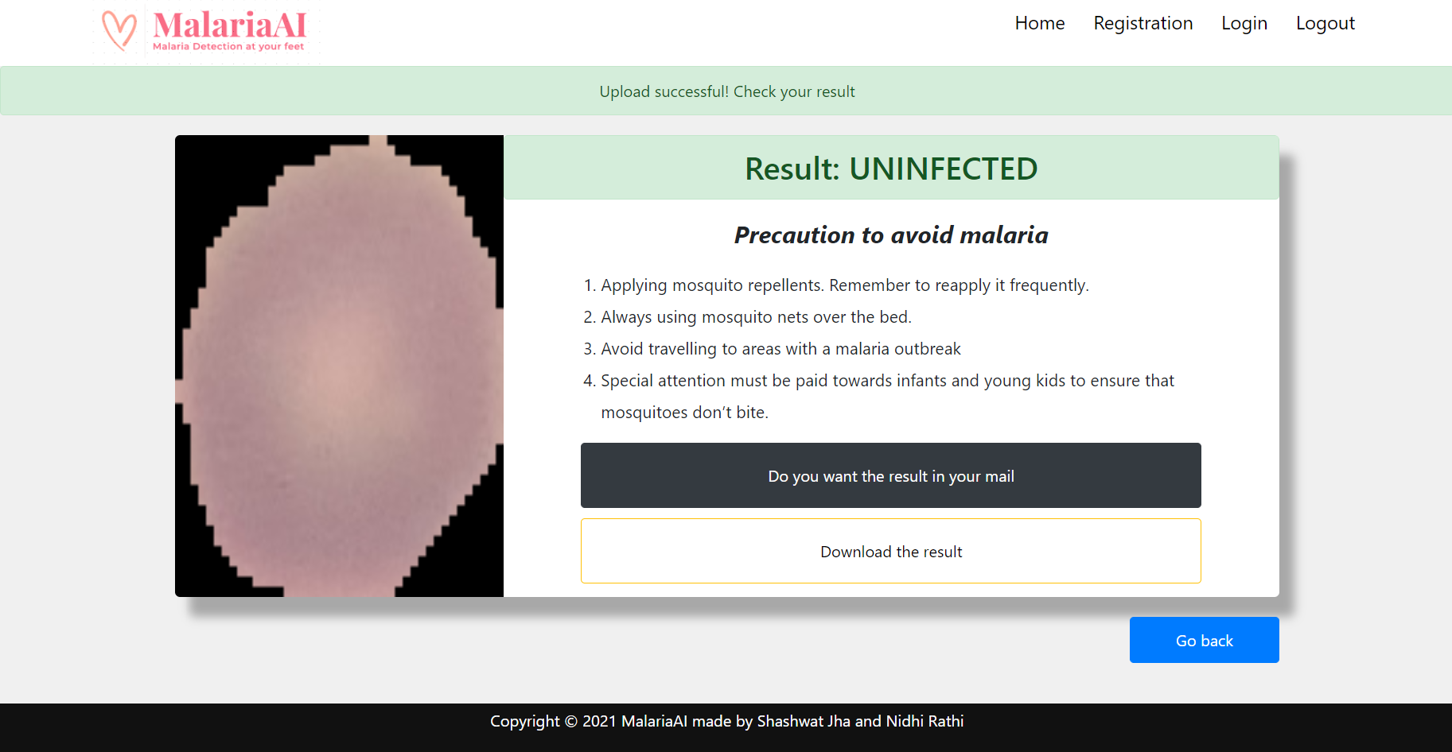

*Email received to patient regarding result*

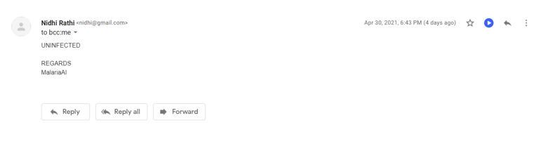

*User can download the result on clicking the download button on result page as a text file with all the details*

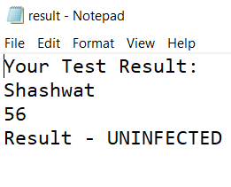

**LOGGING INTO WEBSITE:**

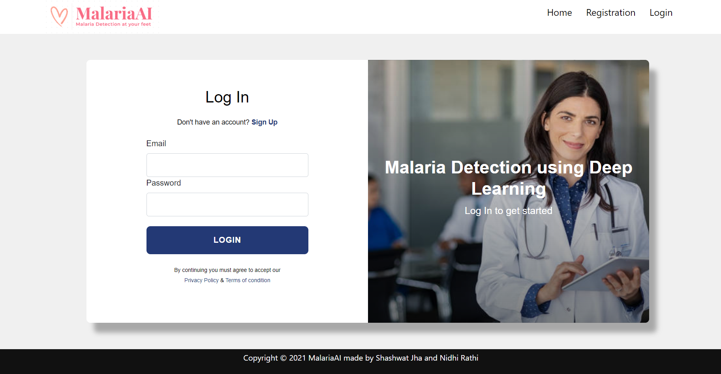

*VALIDATION:*

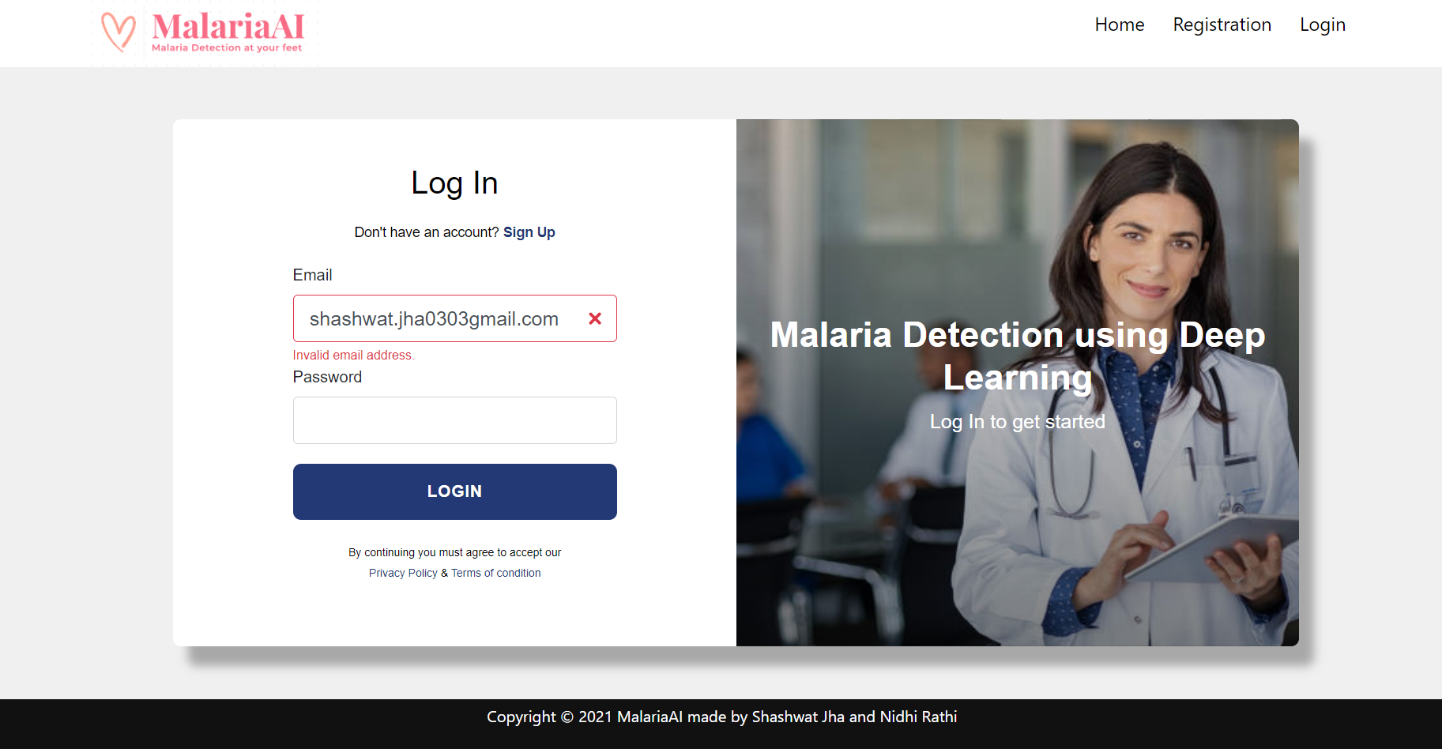

*If email or password is invalid:*

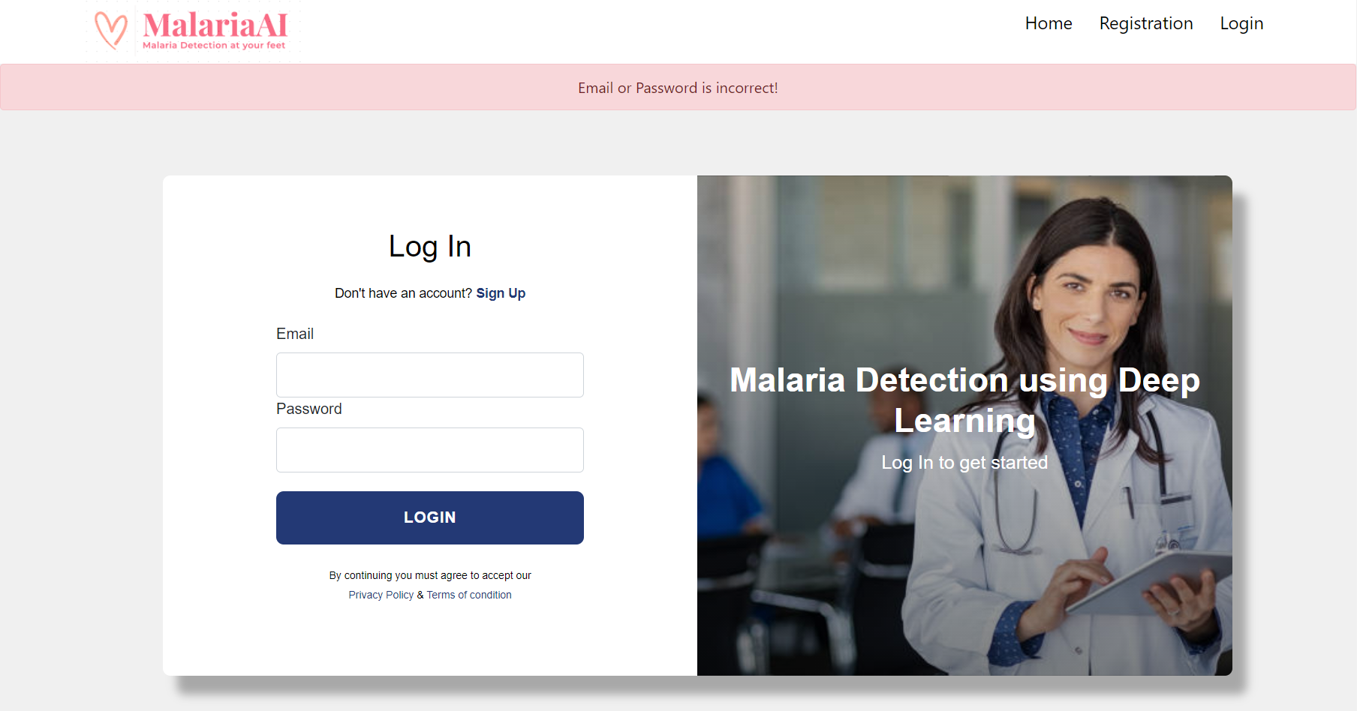

**LOGGING OUT:**

*Clicking on “Logout” will log you out of the image upload/result page and redirect you back to the login page.*

